1.8 inch OLED for Arduino

**operating instructions**

* **1>** [uncompress](javascript:void(0);) Ucglib_Arduino-1.3.3.zip and Copy it to the arduino library directory; **As shown below**
* 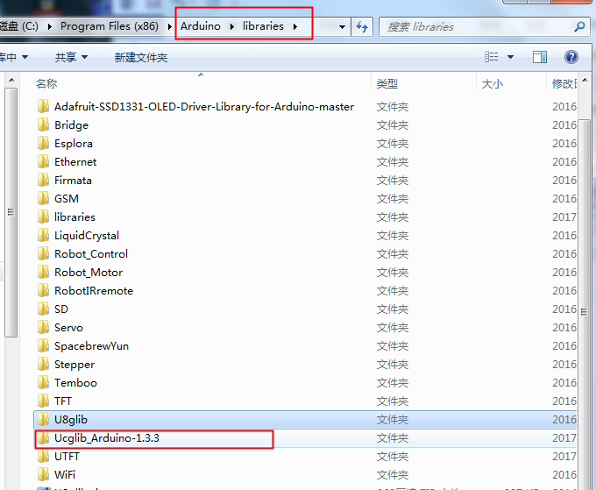
* 2> [opened-file](javascript:void(0);) Ucglib_Arduino-1.3.3\examples
* 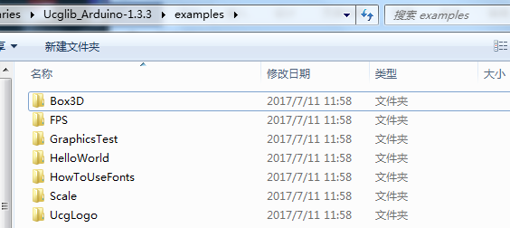
* We can Choose any one file，for example
* 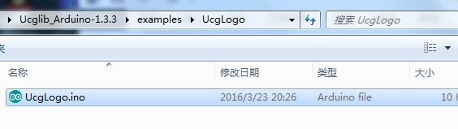 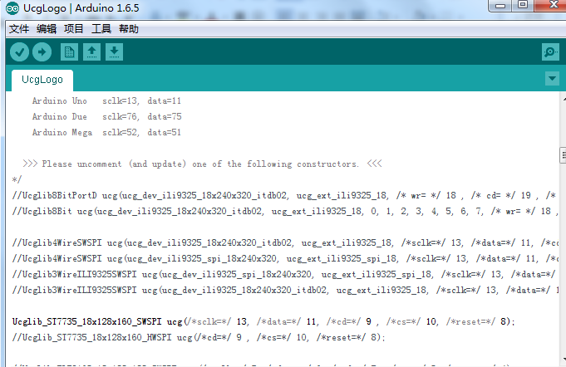
* We chose Ucglib_ST7735_18x128x160_SWSPI ucg(/*sclk=*/ 13, /*data=*/ 11, /*cd=*/ 9 , /*cs=*/ 10, /*reset=*/ 8);
* Remove the front / /
* 4 [compile](javascript:void(0);) and [download](javascript:void(0);)
* 5> [connection](javascript:void(0);) [type](javascript:void(0);)
* Aduino board OLED [display](javascript:void(0);)
* GND GND
* 5V VCC
* 13 SCL
* 11 MOSI(SDA)
* 9 DC
* 10 CS
* 8 RES